# Software Design Document

# PP1

## Introduction

### Product Scope

*Program will allow the user to convert any number base 1-9 to base 10.*

### Requirements

*Program must accurately calculate conversions for numbers base 1-9 to base 10*

### Assumptions

*The user will accurately input their data and will only use digits 0-9*

### Design Overview

### Pseudo Code

*Print prompt for number*

*Read number*

*Print prompt for base*

*Read base*

*Loop through number str until \n found*

*Store loop counter*

*Set pointer to end of str*

*Loop through str*

*Load pointer char*

*If char == \n break*

*Convert char to int*

*Create base multiplier*

*Break if exponent loop counter == str loop counter*

*Multiply working base multiplier by base value*

*Increment counter*

*Multiply pointed char by base multiplier*

*Add result to total*

*Increment counter and decriment pointer*

*Output result*

### Flow Charts

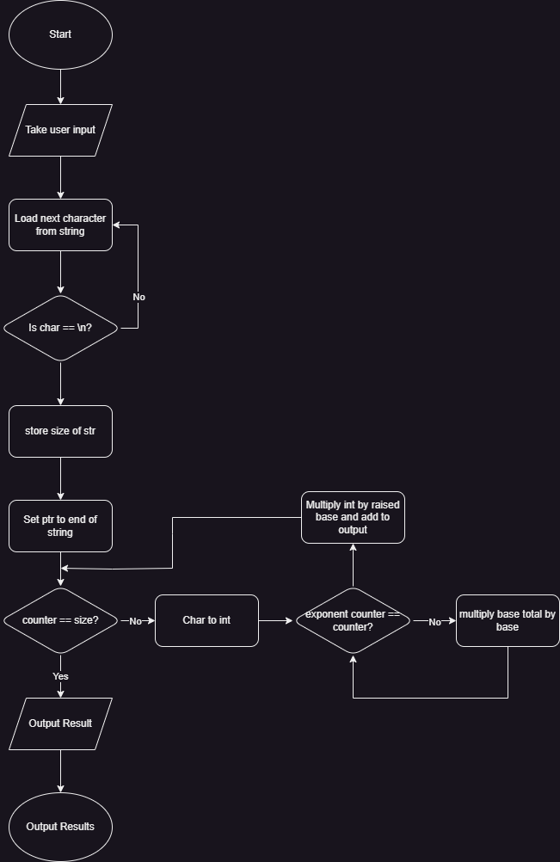

## Class Diagram

*N/A*

## User Interface

*The User will be prompted for their number with it’s base through the terminal, and the resulting conversion will be displayed similarly.*

## Testing

*Passed Test cases:*

* + *101 base 2 - 5*
  + *10101 base 2 - 21*
  + *52 base 8 - 42*
  + *1000 1001 1010 base 2 (no spaces) – 2202*
  + *3011 base 5 – 381*
  + *112010 base 3 - 381*